IHE PCC Profile Proposal

Proposed Profile Name: < Antepartum Ambulatory Prenatal Care Summary >
Proposal Date: <October 2006>
Status: <Draft>
Version History: < Antepartum_Ambulatory_Prenatal_Care_Summary-2006-11-6-mjm.doc>
Editors
Name | Affilliation | e-mail
<Michael J. McCoy, M.D> | <digiChart, Inc.> | <mjmccoy@digichart.com>

1. Brief Description of the Problem:
Obstetrical patients in labor and admitted to Labor and Delivery must have a complete summary of their antepartum ambulatory care available at the time of admission to evaluate and / or ameliorate risk. This same data is required at any visit to Labor and Delivery for any other problems or special needs a patient may require.

As the patient is seen over a finite period in the office, aggregation of specific relevant data is important to the evaluation of the obstetrical patient upon presentation to Labor and Delivery. During the 40 weeks of a typical pregnancy duration, the patient will have had an initial History and Physical Examination, followed by repetitive office visits with multiple laboratory studies, imaging (usually ultrasound) studies, and serial physical examinations with recordings of vital signs, fundal height, and the fetal heart rate. The original New OB History & Physical, ongoing Medical Diagnoses, the Estimated Due Date, outcomes of any prior pregnancies, serial visit data on the appropriate growth of the uterus and assessments of fetal well being, authorizations, laboratory and imaging studies must all be presented and evaluated upon entry to the Labor and Delivery Suite to ensure optimal care for the patient and the fetus.

While for labor patients the planned method of delivery may be vaginal (natural), there is a substantive chance the delivery route may be surgical, requiring anesthesia and post-surgical care.

Current practice is to copy the (paper) chart at various times during the pregnancy (as at 28 weeks and at 36 weeks of completed gestation), and transport the copies of the chart to the hospital the patient intends to use for delivery. Should the patient arrive prior to the chart copy arriving, or if the chart (or information within the chart) is missing on presentation of the patient to Labor and Delivery (a frequent occurrence), often the staff or clinicians repeat laboratory or imaging studies. This results in unwarranted and duplicative tests, is wasteful of time and resources, and leads to dissatisfied patients.
Further, missing or incomplete information about the patient’s clinical status may create a situation where critical information is unavailable to clinicians, which may ultimately result in an injury, inadequate aftercare or other undesirable outcome.

Significantly, a large portion of patients arrive in L&D without complete documentation. In one recent U.S. study, ~70% of patients (with paper charts) arrived in L&D without their current medical record being available. While in this study, only one hospital was involved, one can see the extent of the issue, with pregnant patients possibly going to a different hospital than planned (preterm labor, rapid labor and unable to make it to the planned delivery hospital, or visiting a distant city), moving mid-care, or with a covering physician (rather than the primary obstetrician) on call.

In a Swedish study done in the 1990’s, critical data on paper records were incomplete from 45 to 87.5% of the time. Thus, availability of current medical records remains a significant problem for most hospital Labor and Delivery units; availability of key information electronically will significantly enhance patient safety.

2. Key Use Cases

Use Case 1
Precondition: The patient’s obstetrician sees the patient for her pregnancy in the ambulatory (office) setting. During the pregnancy, the patient is noted to have a medical problem requiring consultation with a Maternal-Fetal Medicine specialist (perinatologist). The office obtains pre-authorization from the insurance payer for the consult, and for the intended or anticipated route of delivery, and transmits that information to both the consultant and to the hospital.

Events: The patient is seen in the obstetrician’s office where a complete medical and relevant social history are taken by the nurse and recorded in the office EHR, incorporating data from the perinatologist’s consultation report as appropriate. Laboratory and imaging reports ordered by the perinatologist as well as the perinatologist’s consultation report are displayed electronically to the obstetrician. The obstetrician reviews the consultation report from the perinatologist’s office and imaging studies ordered by the perinatologist along with data recorded by the nurse. Physical exam reveals some abnormalities. The obstetrician orders additional laboratory studies, and sends the patient to the hospital to Labor and Delivery.

When the laboratory results return, the physician completes the admission H&P, Allergies, Medications, includes the data prepared or ordered by the perinatologist, and makes it available to L&D. This data includes an assessment of the patient’s health status, and the requisite data summarized from the antepartum care given. The charge nurse for L&D documents that the complete collection of documents needed is available. The Post-Partum discharge planning is notified and assures that there is a suitable environment with appropriate support for post-delivery after-care.

Postcondition: The Pre-delivery H&P and Antepartum Summary with appropriate relationships to the Perinatologist Consultation, and all the antepartum laboratory and imaging studies are available to the obstetrician and the birthing center personnel for incorporation into their respective EHRs. The H&P is also available to the patient for viewing and incorporation into the patient’s PHR, and into the newborn baby’s PHR.

3. Standards that might Apply
IHE Medical Summary Implementation Profiles
XDS Folder population

4. Further Discussion.
A folder in XDS may define a collection of documents. In this use case, a collection of documents is described that must be available to the Labor & Delivery staff upon admission to the unit.

In order to demonstrate the utility of this “Antepartum Ambulatory Prenatal Care XDS Folder,” several content profiles must be completed for the various kinds of documents that might be found in the Pre-Procedure Folder. These content profiles would include (existing and new):
- Pre-procedure patient questionnaire
- Pre-procedure H&P (including surgical and relevant social history)
- Summary of OB-specific Ambulatory Visit Data
- Laboratory Reports
- Imaging Reports
- Consultation Reports
- Diagnostic Imaging (Ultrasound) Images
- Non Stress Test (NST) Reports
- NST Waveforms
- Patient Consent Forms for Performance of Procedures
- Payer Authorization Forms
Although the scope of this content profile is limited to the Antepartum Ambulatory Prenatal Care, this discussion illustrates the need to view the aggregation of documents for L&D as the center of multiple related documents and to include in the content profile the mechanisms for specifically referencing these document types.
The stakeholders who use this document for decision making in the course of patient care include:
- Obstetricians and Certified Nurse Midwives
- Perinatologist
- Anesthesiologist
- Labor and Delivery and Peri-operative personnel (L&D staff, surgical coordinator, scheduling, surgical nursing)
- Post-op and Post-Partum Nursing
- Social Work (discharge planning)
- Obstetrician (after discharge)

Because many document sections are shared with other Medical Summary document types, an Antepartum Ambulatory Prenatal Care Summary document would fit in nicely with the IHE collection of Medical Summary Documents. The ability for the IHE Medical Summary documents to incorporate the sections required for an Antepartum Summary as well as the inclusion or reference of imaging and laboratory reports and other clinical documents is an important consideration.

Specifically, this proposal is to publish content profiles for additional sections within the new Section Content Profile Framework being developed and then publish a medical summary document content profile for the full Antepartum Ambulatory Prenatal Care Summary document. The section unique to an Antepartum Ambulatory Prenatal Care Summary is the cumulative aggregation of office visits over the defined prenatal period, coupled with the similar requirements of the Pre-Procedure H&P documentation.

5. Resources/People that could help the technical committee.
The American College of Obstetricians and Gynecologists; The Royal College of Obstetricians and Gynaecologists.

6. Attachments:
ACOG Antepartum Record (paper forms) – for data element definitions

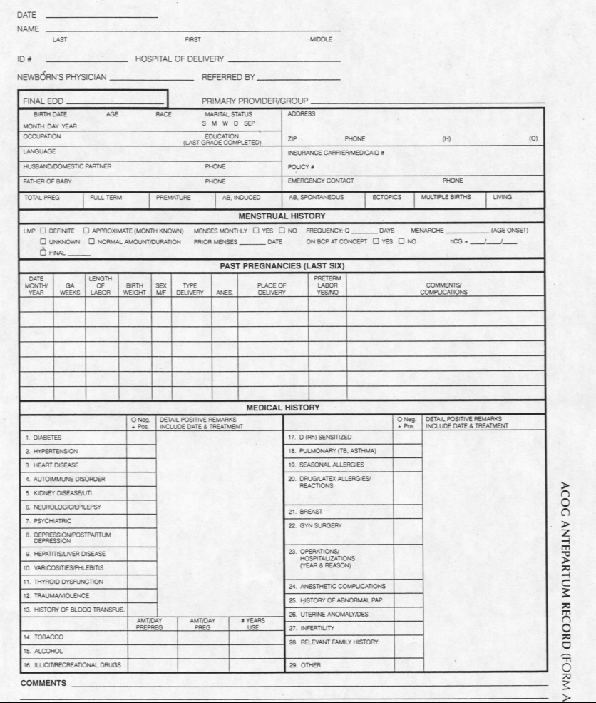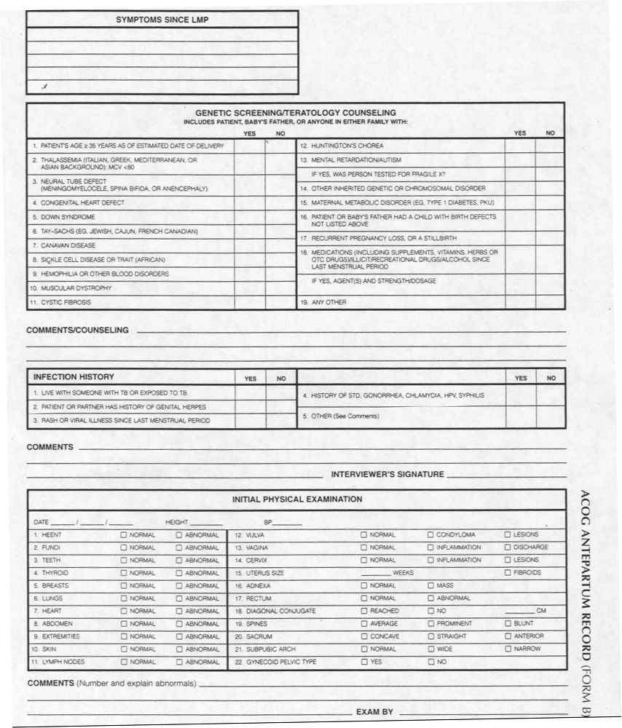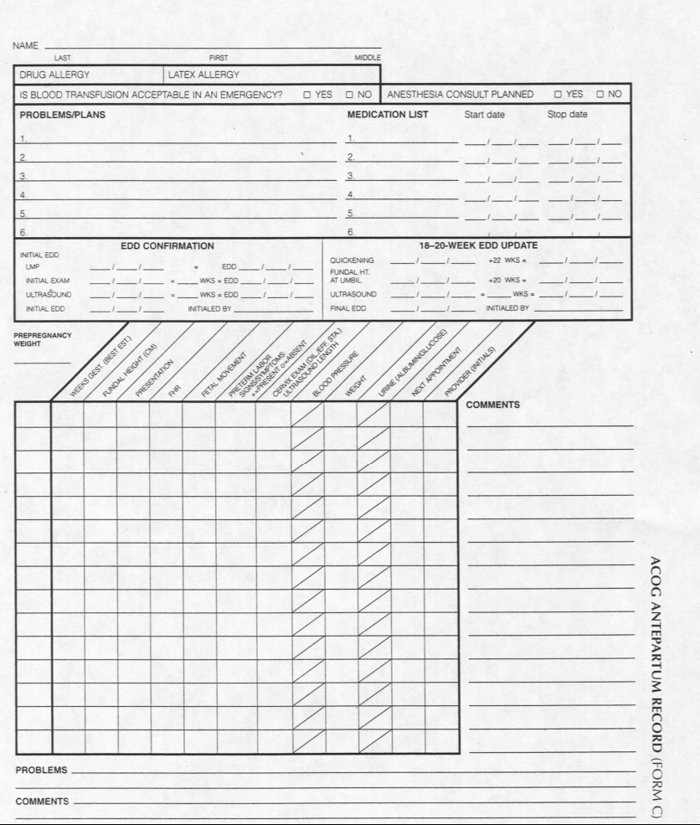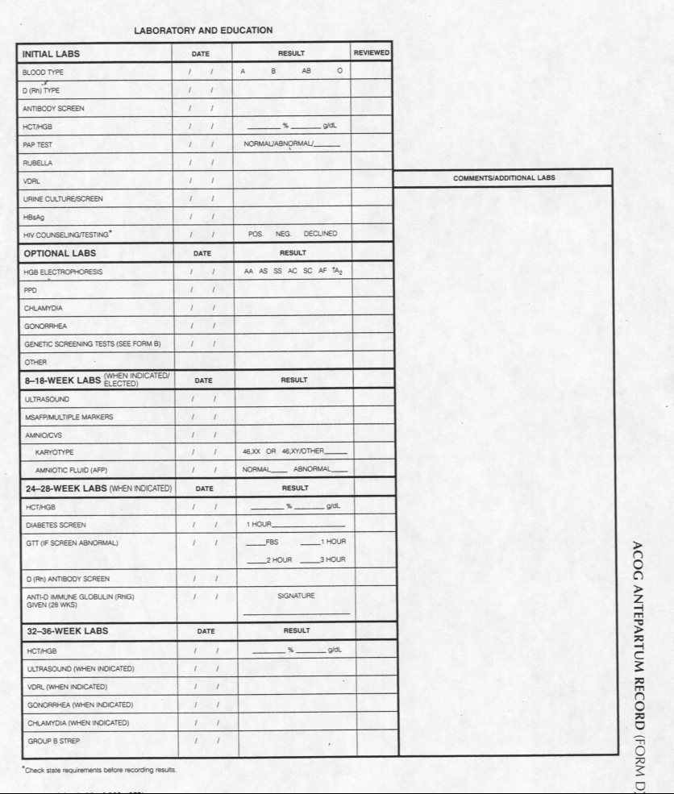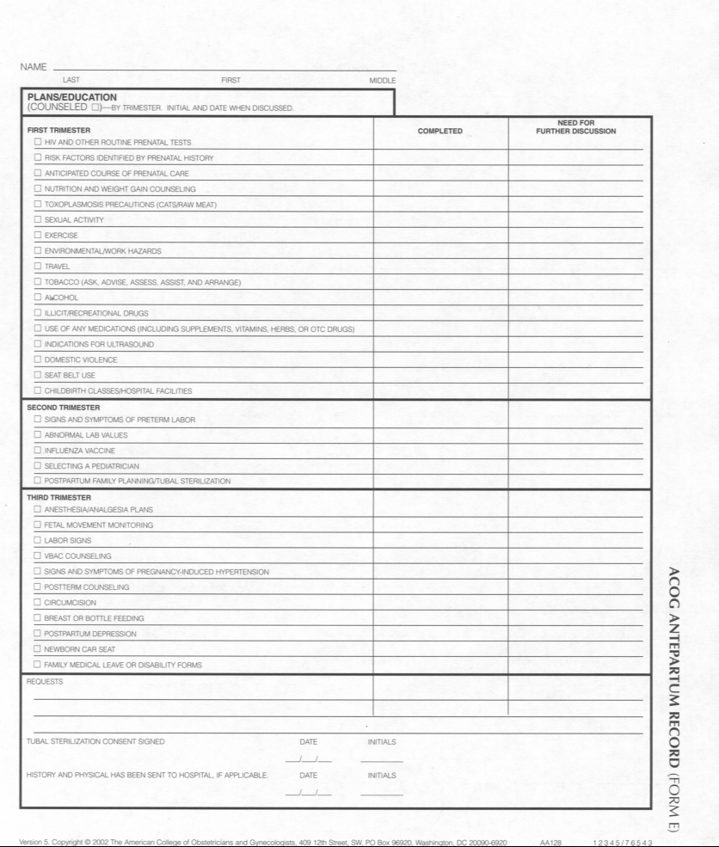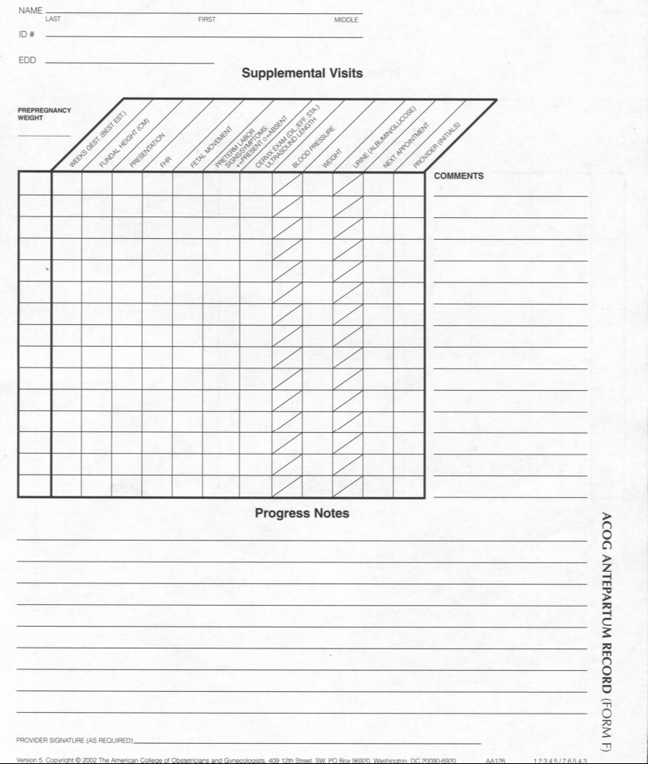

“Missing Prenatal Records at a Birth Center: A Communication Problem Quantified”; Donald W. Miller, Jr., MD, John D. Yeast, MD, MSPH, Robin L. Evans, BSN, RN, AMIA 2005 Symposium, 2005
Presentation at Annual ACOG Meeting; R.B. Beckmann, M.D.; May, 2006
“Primary health care computing analysis of Swedish maternal health records”; A. K. Singh, S. Kohli, K. Moidu, K. Boström, E. Trell and O. Wigertz; Journal of Medical Systems, Volume 18, Number 5 / October, 1994, pages 221-228 (From the Departments of Medical Informatics, Obstetrics and Gynecology, and General Practice, Faculty of Health Sciences, S-581 85 Linköping, Sweden: Abstract: “In our attempt to develop an Essential Data Set for a computer based information system to support Maternal & Child Health Care services an analysis of Swedish maternal care services was undertaken. The present study analyses the information system in the domain of maternal and child health care at the primary health center level with a view to identify areas where a computer-based medical record could effect improvements. The study showed that even in a well organized maternal care service as in Sweden lacunae exist in the information system. The paper forms, called MHV1, MHV2, MHV3 and FV1, though well designed, were incomplete in a large number of the cases. The MHV1 forms were completed in less than 45%, the MHV 2 form in 87.5% and the FV1 form in 70% of the cases. Certain elements of the data set were less likely to be completed than others. Another weak spot was the inaccessibility of the paper records during off-hours. These deficiencies could be eliminated by the use of a computerized medical record based on an essential data set.”)

